**Team Name:** GLR

**Members:** Darwin Guirigay, Josef Lechoncito, and Gavin Rivera

**Overview:**

In the Philippines, many individuals do not seek dental care until they experience pain or discomfort, reflecting a general lack of awareness and education regarding the importance of oral health. The Department of Health reports that oral health issues such as tooth decay and gum disease are highly prevalent across the population, particularly among children. A national survey further indicates that over 90% of Filipinos suffer from dental caries, yet routine dental visits remain uncommon. Experts attribute this behavior to limited understanding of preventive care and the long-term benefits of proper oral hygiene from an early age. Additionally, financial constraints and inadequate access to dental services make it difficult for many families to address oral health concerns before they worsen. These factors highlight the urgent need to strengthen oral health education and promote greater awareness across communities in the Philippines.

**Solving the Problem:**

With oral health problems such as dental caries affecting over 90% of Filipinos and the lack of regular dental visits due to cost, distance, or limited access to clinics, our team proposes a solution by developing a web-based platform integrated with an Arduino-powered periscope imaging device. This system will allow users to capture intraoral images and receive free dental health assessments through AI-powered analysis.

**The Application:**

* **Application Name:** Dental Lens: An Arduino-Powered Rotational Imaging System with AI-Based Diagnostic Analysis for Oral Health Assessment
* **What is is:**
  + A web-based platform designed by our team to address the lack of accessible and preventive dental care in the Philippines. The platform aims to provide free dental health assessments using a combination of AI image analysis and an Arduino-powered periscope imaging device. Users can upload intraoral images captured through the device, and the system will detect signs of potential oral diseases like dental caries, gingivitis, and more.
* **Features:**

The team plans to include the following features in the platform:

* **Image Upload and AI Assessment**

Users can upload clear mouth or intraoral images captured using the Arduino-based imaging device. The AI will analyze the image and identify early signs of dental issues.

* **Basic Risk Summary**

After analysis, the system will generate a simplified, easy-to-understand risk summary based on what the AI detects from the image (e.g., signs of cavities, gum issues).

* **Preventive Care Tips**

The platform will suggest preventive care routines based on the identified risks to promote awareness and encourage oral hygiene practices.

* **Remote Scan Records**

Users can create an account to track previous scans, allowing them to monitor changes in oral health over time.

* **Accessible Interface**

Designed for mobile and desktop use with clear navigation, the platform ensures accessibility even in areas with low internet bandwidth.

* **Questions about the application:** 
  + **Who are the potential users?**

The potential users of this dental health assessment platform include anyone who wishes to monitor their oral health conveniently. This may range from children and adults to the elderly, regardless of location or economic background. The platform is designed to be inclusive, serving people who are curious about their dental condition, those who want to avoid costly dental visits, or individuals who simply want to practice better preventive care. Since it’s accessible online, it also caters to users who prefer digital tools over traditional checkups.

* **What tasks do they seek to perform?**

These users primarily aim to perform basic dental health assessments without the need to visit a clinic. They want to capture and upload intraoral images using a connected device, receive AI-generated assessments of their oral condition, and gain insights or tips on how to improve their dental hygiene. Some may also want to track their oral health progress over time or use the tool to determine whether professional dental consultation is needed**.**

* **What functionality should any system provide to these users?**

The system should allow users to easily upload mouth images, receive real-time analysis using AI, and access educational materials on dental hygiene. It should support multilingual access, work efficiently on mobile devices, and store scan history for future reference. A user-friendly interface with clear guidance on image capture and results interpretation is important.

* **What constraints will be placed on your eventual design?**

Several constraints need to be considered. The system must function reliably in low-bandwidth areas and on low-cost devices, ensuring accessibility for the target demographic. Since it handles health-related data, it must also comply with data privacy and security regulations. The hardware used (Arduino-powered periscope) must be affordable and easy to maintain. Furthermore, the AI model must be trained to work accurately across diverse image qualities and oral conditions.

* **What criteria should be used to judge if your design is a success or not?**

Success will be measured by the accuracy of the AI in detecting early signs of oral diseases, the number of users actively engaging with the platform, and the system's ability to function well in various environments. User satisfaction and feedback will also serve as important indicators, particularly in assessing ease of use and clarity of results. Ultimately, the platform’s success lies in its capacity to improve awareness, encourage preventive care, and reduce the gap in access to basic dental health services.

* **Approach:**

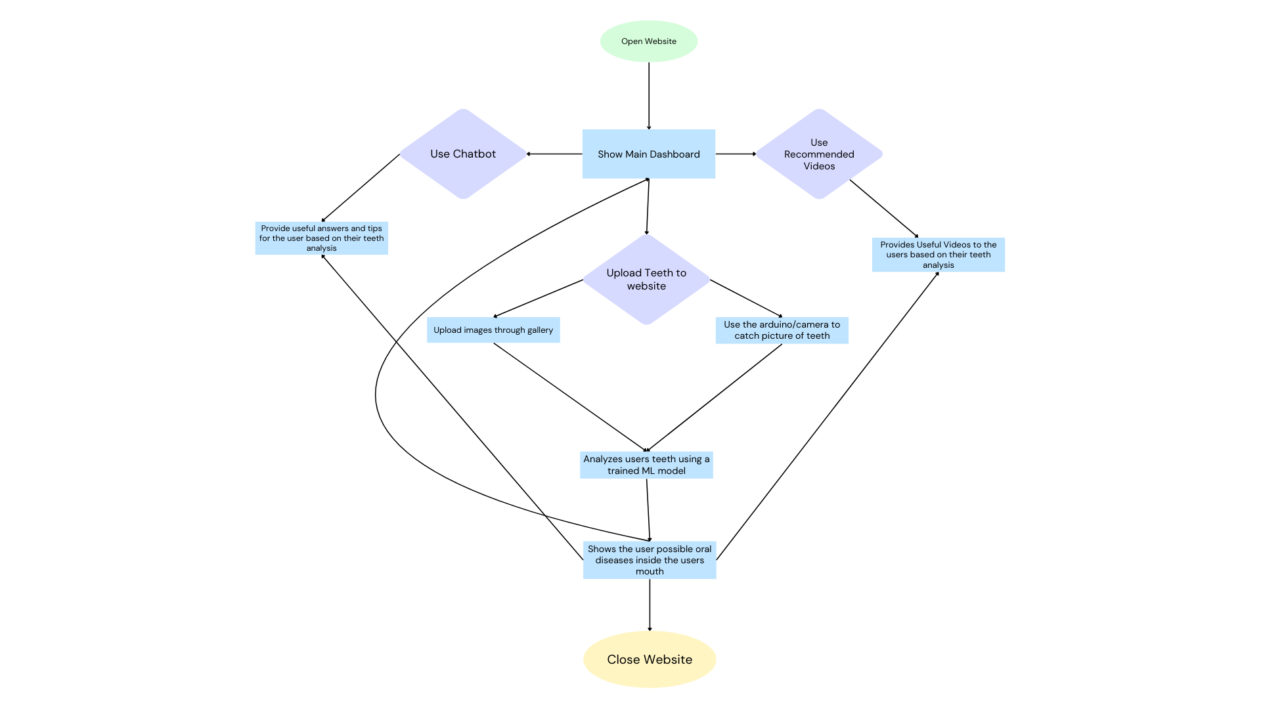

***Figure 1. Flowchart***